

# MINI PROJECT REPORT

*On*

PERSONALIZED LEARNING PLATFORM USING ARTIFICIAL INTELLIGENCE

*Submitted in partial fulfilment for the award of degree of*

***Master of Computer Applications***

*By*

Abhiram A K (MLM23MCA-2001)

Under the Guidance of

Banu Sumayya S

(Assistant Professor, Dept. of Computer Applications)

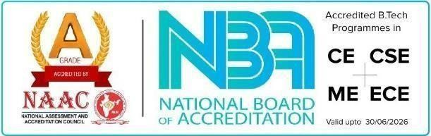

# DEPARTMENT OF COMPUTER APPLICATIONS

# MANGALAM COLLEGE OF ENGINEERING, ETTUMANOOR

***(Affiliated to APJ Abdul Kalam Technological University)***

NOVEMBER 2024

MANGALAM COLLEGE OF ENGINEERING, ETTUMANOOR DEPARTMENT OF COMPUTER APPLICAATIONS

NOVEMBER 2024



***CERTIFICATE***

*This is to certify that the Project titled* ***“Personalized Learning Platform using Artificial Intelligence (LearnLab)”*** *is the bonafide record of the work done by* ***ABHIRAM A K (MLM23MCA-2001****)of Master of Computer Applications towards the partial fulfilment of the requirement for the award of the* ***DEGREE OF MASTER OF COMPUTER APPLICATIONS by APJ ABDUL KALAM TECHNOLOGICAL UNIVERSITY****, during the academic year 2024-25.*

**Internal Examiner**

**Project Guide**

**Banu Sumayya S Assistant Professor**

**Dep.Of Compter**

**Applications**

**Head of the Department**

**Ms.Divya S.B**

**Associate Professor**

**Dep.Of Compter**

**Applications**